C29PE Tutorial 1 - Questions and Answers

‘Warm up’ questions

- Economists study many issues, but all of them stem from the central economic problem of scarcity. Scarcity arises because there are constraints for both consumers (e.g. limited time, information and income) and sellers (e.g. limited resources to produce goods and services, perhaps because of a shortage of skilled labour). Some people suggest that the problem of scarcity will eventually disappear with the development of new technology and resulting higher levels of production.

- Is this statement true or false? Set out your thinking.
Explain: As production rises, so will people’s incomes. People will thus choose to buy more. Also, firms will stimulate consumer demand through advertising and other forms of product promotion. So, as supply increases, so too will demand. Scarcity will not disappear.

b) Because of scarcity we have to make choices about which goods and services we desire most.
i) Explain the concept of opportunity cost.
ii) What is the opportunity cost of you attending today’s tutorial?

Choices involve sacrifices or costs. If as a society we consume more of one good or service then, unless there are idle resources, we will be able to consume less of other goods and services.
The cost of one good measured in terms of the best alternative we have to sacrifice is called the opportunity cost.
The opportunity cost of attending today’s tutorial could be an hour’s studying in the library, an hour in bed, a run around the campus.

- According to the Structure–Conduct–Performance paradigm, what determines business performance?
In this paradigm the performance of a business is strongly influenced by the market structure within which it operates. Business in highly competitive markets will behave differently from those in less competitive markets. Competitive structure influences firm conduct (pricing strategies, advertising, innovation, etc.) which in turn influences performance (profitability, efficiency, etc.).

- You won a free ticket to see a concert tonight. You cannot re-sell the ticket. On the same night your favourite sports team is playing, and watching your team play is the only other activity you are considering tonight. You must therefore decide whether to watch the concert or watch your team play. The ticket to watch your team play costs £40 and you are willing to pay as much as £50 for the chance to see your sports team perform. What is your opportunity cost of going to the concert? (Hint: if you give up watching your sports team what is the value of your sacrifice?)
The option of watching the sports team perform is worth £50, while the cost of a ticket is £40. So the net gain to the individual is £10 for this option. If this option is forgone, the value of this sacrifice is simply £10.

Sample exam questions

- A retailer of winter clothing purchases winter coats from a supplier at £200 per coat. During the winter season, the coats will sell at prices higher than £200 per coat. After winter is over, the retailer finds that there are still some remaining stock of winter coats that are still unsold. However, the unsold coats are no longer in demand after winter. The retailer has an option to re-sell these winter coats to the supplier at a 60% discount of the original purchase price of £200.
- Before the retailer purchased any winter coats from the supplier, what is the opportunity cost of buying the winter coats from the supplier? (3 marks)
The value the retailer could have derived from spending £200 X (quantity of coats) on the next best alternative. If the retailer spends on winter coats, it can no longer use the money to spend on other items
- After purchasing the winter coats from the supplier, what is the retailer’s opportunity cost of selling the coats to a customer? (3 marks)
If the retailer does not sell to the customer, the only other alternative is to sell the coats back to the supplier at 60% discount (i.e £80)
- As winter is about end, the retailer finds that there is a large stock of unsold winter coats. The retailer has been selling winter coats to customers at £800/coat. The store manager argues that the price should be reduced to £95/coat and try to sell the remaining coats before they become redundant after winter. However, the owner of the retail store disagreed as this would mean selling at a loss of £105 (£200-£95) per coat. Which argument makes economic sense? The store manager’s argument or the retail shop owner’s argument? (4 marks)
The retailer has paid £200 for the winter coats so this is a sunk cost and no longer relevant to decision-making. It is unlikely for the remaining coats to be sold at £800 per coat. The next alternative is to re-sell these coats to the supplier at £80 per coat. Compared to £80, the store manager’s suggestion of selling at £95 makes more sense.

- The manager of a firm that produces coffee beverages is considering whether to increase the price of its products. The manager is concerned about how much demand will fall if price increased.

- Define price elasticity of demand and describe why it is a useful tool for firms.
[3 marks]

Price elasticity of demand shows the responsiveness/sensitivity of quantity demanded to a change in the price of the product.

It helps firms to determine whether an increase in price will lead to a proportionately larger or smaller fall in quantity demanded. Hence, the firm will be able to assess if an increase in price will lead to an increase or decrease in total revenue.

- Calculate the price elasticity of demand for coffee if the number of cups demanded falls from 500 to 350 cups per month when the average price is increased from £15 to £25.
[2 marks]

Change in quantity demanded = -150 / 500 = -3/10
Change in price = 10 / 15 = 10/15 = 2/3
Price elasticity of demand = -0.45

(i) Interpret the price elasticity of demand coefficient calculated in part b). (ii) Identify one of the main factors determining the price elasticity of demand for coffee?
[2 marks]

Price elasticity of demand at this change in price is price inelastic because the value (after omitting the negative sign) is smaller than one.

The main factors determining the price elasticity of demand in this example, are likely to be the number and closeness of substitutes (it is likely that there are few substitutes) or the degree of necessity of the good (coffee seems to be an important drink to the customers).

- Calculate what will happen to total revenue if the manager decides to go ahead with the price change detailed in part b). Suggest an alternative option to increasing price if the firm wants to try and increase total revenue.
[3 marks]
Total revenue would rise from £7500 per week (500 x £15) to £8750 (350 x £25).

The firm could try and find new markets, introduce some form of product differentiation or use advertising.

Supplementary questions (will not be discussed in class)

- How will the market demand curve for a ‘normal’ good shift (i.e. left, right or no shift) and what will happen to the equilibrium price in each of the following cases?
You should know that a ‘normal’ good is a good whose demand rises as people’s incomes rise.

- The price of a substitute good falls
The demand curve shifts to the left, so the market price and the quantity traded fall.

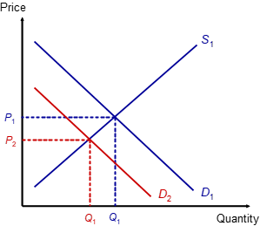

- The population rises
The demand curve shifts to the right, so the market price and the quantity traded increase. [Useful to remember – if the demand curve shifts, and the supply curve does not move, then the shift in demand leads to a movement along the supply curve.]

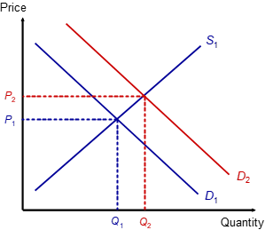

- Tastes shift away from the good
The demand curve shifts to the left. Diagram as in a)

- The price of a complementary good falls
Demand for complements increase together. If the price of a good falls, then the demand rises. The demand for the good’s complements also rises. Analysis as in b)

- The good becomes more expensive
Slight trick – shifts mean that there’s a change in something other than the good’s own price. So there’s no shift here just a movement up the demand curve.

2. How will the market supply curve of a good shift (i.e. left, right or no shift) in each of the following cases? What will happen to the market price and the quantity traded.

- Costs of production fall
If it is cheaper to produce the good, then there is more profit per unit produced. The supply curve shifts to the right. There will be a movement down the demand curve to the new equilibrium. Market price falls, quantity traded increases.

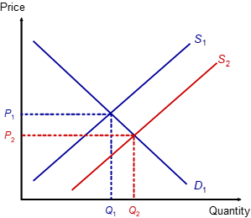

- Alternative products (in supply) become more profitable
This means that firms will switch production to the alternatives, so that at any price the quantity supplied of this good will fall. The supply curve shift to the left. There is a movement up the demand curve. The market price rises, and the quantity traded falls.

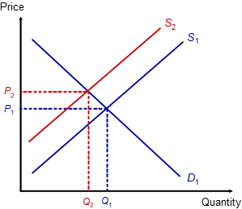

- The price of the good rises.
Remember – a price rise means that there is a movement along the curve, not a shift of the curve.
- Firms anticipate that the price of the good is about to fall.
Useful to remember that anticipate means taking action when expecting something to happen. So if firms think that the price of the good is about to fall, they will start to reduce production – supply curve shifts left. Analysis as in b)

3. The demand and supply schedules for wheat in a free market are as follows:

Price per tonne (£) | 120 | 160 | 200 | 240 | 280 | 320 | 360 | 400
Tonnes demanded per week | 725 | 700 | 675 | 650 | 600 | 550 | 500 | 425
Tonnes supplied per week | 225 | 300 | 400 | 500 | 600 | 750 | 1000 | 1300

- Draw the demand and supply curves on a diagram:

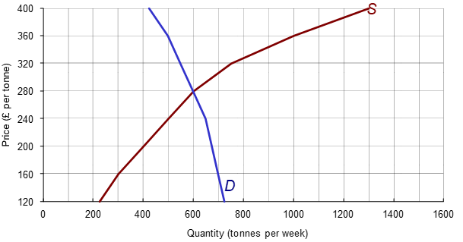

- What is the equilibrium price and quantity traded?
Looking for the intersection: £280 per tonne (where D = S = 600 tonnes)

- Suppose the government fixes a maximum price of £200 per tonne. What will be the effect?
Reading off the graph or the table: shortage of 275 tonnes (675 – 400)

- Suppose that supply now increases by 150 tonnes at all prices. Enter the new figures.

Price per tonne (£) | 120 | 160 | 200 | 240 | 280 | 320 | 360 | 400
Tonnes demanded per week | 725 | 700 | 675 | 650 | 600 | 550 | 500 | 425
(old) Tonnes supplied per week | 225 | 300 | 400 | 500 | 600 | 750 | 1000 | 1300
(new) Tonnes supplied per week | 375 | 450 | 550 | 650 | 750 | 900 | 1150 | 1450

- How much will price change from the original equilibrium (assuming that the government no longer fixes a maximum price)? How much more will be sold?
From the table, the price will fall by £40 to £240, and the quantity will rise by 50 from 600 to 650 (less than the increase of 150 in supply because the market price has also increased)

